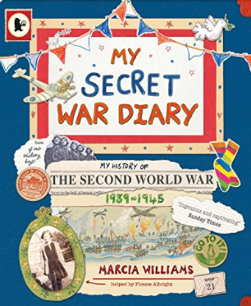  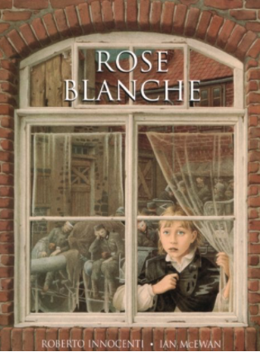 | Home Challenges – Tawny Owls and Woodpecker Class  Autumn Term One  ’My Secret War Diary’ by Marcia Williams and ‘Rose Blanche’ by Ian McEwan and Roberto Innocenti (Illustrator).  What was the impact of World War 2 on Britain ?  You can choose how you would like to present your homework.  We are looking forward to seeing your homework completed to a high standard.  You may find the website below useful for researching the topic.  http://www.primaryhomeworkhelp.co.uk/Britain.html

Present World War 2 in numbers. | Design a WW2 propaganda poster | Research and make a WW2 rationing recipe | Write a descriptive piece about an air raid. | Write a biography of a famous person associated with WW2.
What 6 things would you take with you as an evacuee and why ? | Create your own model tank or gas mask. | Create a graph comparing the size of armies from different nations. | Draw and label an aeroplane from WW2 e.g. Spitfire. | Write a song to keep people's spirits up during the war.
Research how WW2 affected your family or the local area. | Write a war based poem.

