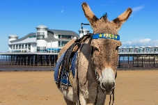
Hedgehogs and Kingfishers Home Challenges – Summer Term 2
Please remember that the most important homework for your child to complete is daily reading. In addition, your child could complete the home learning challenge each week. Homework books are due in on a Wednesday to be marked and sent back home on a Friday.

This term we are focusing on the seaside and the human and physical features of these areas. During this topic we will be looking at a variety of text types including texts by our author of the half term – Benji Davies.

If you wish, please complete each activity and hand it in when you have completed it, so we can celebrate it in the class. Please ask if you need any help or resources.

Week 1: | Week 2: | Week 3: | Week 4: | Week 5: | Week 6: | Week 7:
Wish you were here!  Create a seaside postcard, of a beach you have visited with a picture on the front and writing on the back.  If you happen to visit a beach soon, send us a real postcard. 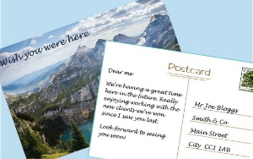 | Is that treasure I see?  Create a seaside treasure map with clues. E.g. Walk 10 steps forward and then a quarter turn to the right. X marks the spot.  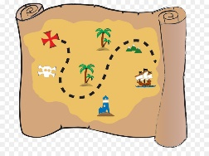 | Dictionary corner  Create a seaside vocabulary poster. Make it bright and colourful.  sand rock  sun waves  rock pools | Lighthouses  Research facts about the history of lighthouses.  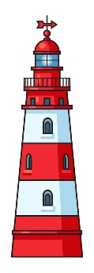  Draw a diagram and label. | How much?  Pretend that you work in a seaside shop. What items do you sell? Write a price list for all of the items in your shop. Does your shop have any special offers?  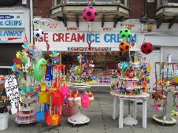 | Roll the dice  Create a seaside themed board game. e.g. Waves and Surf boards  Don’t forget to include the rules!  Try playing it with your friends and family and see who wins.  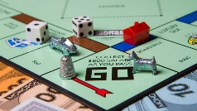 | In the past  Draw a picture of a seaside scene from either the past or today. What will people wear? What will be on the beach?  

