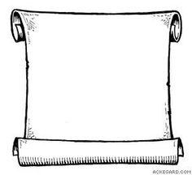
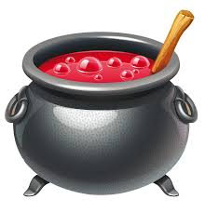
Can you adapt the recipe for this potion found in a dusty old magic book…?
Potion for 1 teacher
Potion for 9 teachers
A Student’s Potion:
Adapt the potion for 9 teachers.
A Student’s Potion:
To make teachers do exactly what YOU want!
9 squashed bugs
15 used tissues
1 piece of chewing gum
3/4 of a chewed pencil
30 scrunched up homeworks
Potion for 3 teachers
Silver
A Student’s Potion:
Adapt the potion for 1 teacher.
Can you adapt the recipe for this potion found in a dusty old magic book…?
Silver
Potion for 20 students
A Teacher’s Potion:
Adapt the potion for 1 student.
Potion for 1 student
Potion for 5 students
A Teacher’s Potion:
Adapt the potion for 20 students.
A Teacher’s Potion:
To make naughty pupils behave like angels
5 school jumpers
10 student noses
2 and 1/2 toenails from a star pupil
100 germs of a school laptop

