

Special Educational Needs
and
Disability Policy

Status: | STATUTORY
Responsible person: | HEADTEACHER
Responsible Governor: | SEND GOVERNOR
Ratified by the Head Teacher: | December 2022
Date first approved by the Governing Body: | December 2018
Review Period: | Annually
Review Date: | December 2026

SEND Policy

Schools have a duty to report to parents on the provision for SEND and implementation of their disability equality scheme. The Special Educational Needs and Disability Code of Practice (January 2015) lies at the heart of the school’s SEND policy and sets out the processes and procedures that all organisations should follow to meet the needs of children. The Code describes a graduated approach which recognises that children learn in different ways and can have different types of SEND. We recognise that every teacher is a teacher of special needs and the implementation of this policy is the responsibility of all staff.

The name and contact details of the SEND co-ordinator (SENDCo):

Mr David Adfield 01823 662317 available Monday to Thursday.

Names of Designated Teacher Safeguarding and SEND Governor, and contact details

Mr Michael Berrisford Head Teacher 01823 662317
Mr David Adfield 01823 662317
Mrs Susan Leaver SEN Governor

Key legislation which has been taken in to account

This policy was reviewed and updated in line with the revised Special Educational Needs and Disability Code of Practice 0-25 Guidance and Children and Families Act January 2015. It should be read in conjunction with the policies on teaching and learning, the school curriculum, equality and assessment. The accessibility plan is an integral part of this policy.

Purpose of Policy:

At Rockwell Green Primary School, we believe that each pupil has individual and unique needs. We acknowledge that a significant proportion of pupils will have special educational needs (SEND) at some time in their school career. Many of these pupils may require help throughout their time in school, while others may need a little extra support for a short period to help them overcome more temporary needs. If these pupils are to have meaningful access to the National Curriculum and achieve their full potential, we must recognise this and plan accordingly. We aim to provide all pupils with strategies for dealing with their needs in a caring, friendly and safe environment. We want our children to be confident, able people, who possess a sense of personal duty and an understanding of the Christian ethos and values to enable them to make the best contribution possible to the community in which they live.

Identification of SEN (COP 6.15).

The 2015 Code of Practice says that:
6.15
A pupil has SEN where their learning difficulty or disability calls for special
educational provision, namely provision different from or additional to that normally available to pupils of the same age. Making higher quality teaching normally available to the whole class is likely to mean that fewer pupils will require such support. Such improvements in whole-class provision tend to be more cost effective and sustainable.
6.17
Class and subject teachers, supported by the senior leadership team, should make regular assessments of progress for all pupils. These should seek to identify pupils making less than expected progress given their age and individual circumstances. This can be characterised by progress which:
• is significantly slower than that of their peers starting from the same baseline
• fails to match or better the child’s previous rate of progress
• fails to close the attainment gap between the child and their peers
• widens the attainment gap

The Graduated Approach to SEND support:

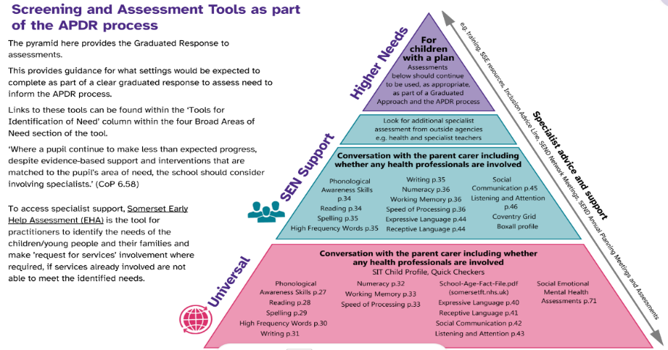
Children with special educational needs have learning difficulties that call for special provision to be made. Any child may have special needs at some time in their school lives.
All children at Rockwell Green Church of England Primary School are monitored closely by their class teachers. This is done through on-going observation and assessment and regular Pupil Progress Meetings to discuss individual needs and progress. We have developed a graduated response to identifying and supporting children with additional needs in line with the Somerset Framework and make use of the Somerset Graduated Response Tool which can be found here:
https://www.somerset.gov.uk/children-families-and-education/the-local-offer/education/what-to-expect-from-education/

This approach takes the form of a four-part cycle through which earlier decisions and actions are reviewed and amended with a growing understanding of the pupil’s needs and of what supports the pupil in making good progress. It begins with high quality inclusive teaching, incorporating a range of learning styles and appropriate learning objectives matched to the needs of the children. It may also include seeking advice from external agencies, with the consent of the Parent/Carers, when required, in order to help children to overcome their difficulties.
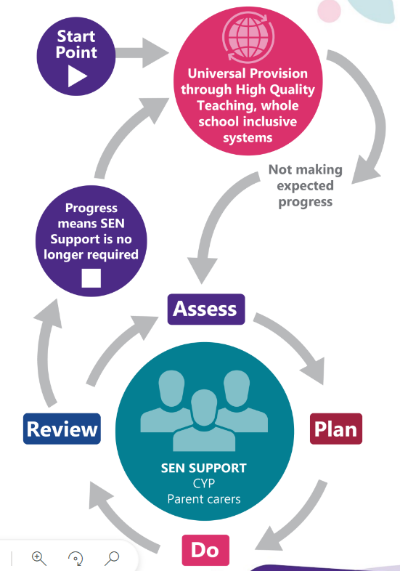

Assess
During their time in school, all children are assessed against nationally set criteria to check their progress across the curriculum. It is through this process that children who are not making expected progress are highlighted. In identifying a child as needing SEND support the class teacher and the SENDCo gather information in order to identify the pupil’s needs and any barriers to learning. This process draws on the teacher’s assessment and knowledge of the pupil, their previous progress and attainment, the views of both pupil and parents and may involve a classroom observation and/or additional assessments by the SEND Team as well as advice from external support services, where relevant. Where professionals are not already working with school staff parents may be asked to give permission for any necessary referrals to outside agencies to support their child’s learning.

Plan
Where it is decided to provide a pupil with SEND support, the parents will be formally notified and the child’s needs recorded on the SEND Register. An Individual Learning Plan is drawn up, identifying the needs, support strategies and how the child learns best, as well as the expected impact on progress and learning outcomes. The Individual Learning Plan is shared with parents and all teachers or support staff who work with the pupil. As a school, we believe that parents have an important role in reinforcing or supporting the learning that is taking place in school.

Do
The class teacher remains responsible for working with the child on a daily basis and retains responsibility for the pupil even when the interventions involve group or one-to-one teaching away from the class. They oversee, plan and work with each child with additional needs in the class to ensure that progress in every area is made. They work closely with any teaching assistants or specialist staff involved, to plan and assess the impact of support and interventions and how they can be linked to classroom teaching. The SENDCo will support the class teacher in the further assessment of the child’s needs and with problem-solving effective ways of overcoming barriers to learning.

Review
The effectiveness of the support and interventions and their impact on the pupil’s progress will be reviewed termly. The class teacher, TA and SENDCo monitor and evaluate the progress and provision for each child. The views of the parents are also sought and any changes to the support are discussed. Where a pupil has an Education and Health Care (EHC) plan, an annual review is held and submitted to the local authority, who will amend the plan accordingly.

As a school, we are committed to providing quality first teaching. We have high expectations of our children and provision across the school is as inclusive as possible. We aim to provide equal opportunities for all pupils, whatever their age, gender, ethnicity, attainment and background, and adhere to our school values of respect, trust, justice, service, compassion and friendship. In addition, pupils are encouraged to develop the core learning behaviours of determination, communication and curiosity in all areas of the curriculum. A range of groupings are used in the classroom and opportunities provided for pupils to work at their own pace with and without support. Lessons have clear learning objectives and assessment is used to inform the next stage of learning. Adjustments to lessons are made depending on the needs of the individuals within a class. Observation, marking and assessment inform Teachers’ planning to ensure all work is accurately matched to the needs of all children. Groupings of children can change regularly according to needs and understanding.

The SEND register process – placement on and exit criteria
The class teacher will use assessments and universal strategies outlined in the Somerset Graduated Response Tool to gather evidence of the child’s strengths and needs and complete the SEN referral form (Appendix 1 below sets out the different stages of identifying a pupil with SEN and the steps to take within each). Before a child is placed on the SEN register, the class teacher will discuss their potential concerns with parents so that a whole picture can be gathered around the child’s needs.

If a child is identified as having a special educational need, according to the definition above, their name will be recorded on the SEND register and parents notified. Their progress will be monitored regularly and the effectiveness of the support provided will be evaluated termly. If the child makes accelerated progress and it is felt that this is sustainable without SEND provision being made for them, parents, Class Teacher, SENDCO and any outside agencies involved will discuss whether the child’s name should be removed from the register. The views of the child will also be taken into account. The child will then be monitored closely via the school’s monitoring procedures to ensure they continue to thrive. Parents will be encouraged to be actively involved throughout the process. SEND records will be kept until the child leaves school and then passed on to the next setting.

EHC Plans

Where, despite the school having taken appropriate action to identify, assess and meet the special educational need of the child, he or she has not made expected progress, the school or parents may consider requesting an Education, Health and Care needs assessment. Education Health Care Plan procedures are implemented in accordance with LA guidelines. The SENDCO co-ordinates school advice submitted to the LA as part of the EHCP process.
Further information about applying for an EHCP in Somerset can be found here:

https://www.somerset.gov.uk/children-families-and-education/the-local-offer/education-health-and-care-plans/

Participation of Pupils:

We want all our children to feel that they are a valued part of our school community and their views are regularly sought. We recognise that all children have the right to be treated with dignity and fairness, to be protected, to develop their talents and abilities to their full potential and to have opportunities to express their views, be listened to and influence positive change in the school. We have a Pupil Task Force elected by their peers which meets regularly during the school year, and their opinions are sought on a range of issues, when appropriate. These then feed into future planning.
Children regularly have the opportunity to discuss their learning and metacognitive strategies, to help them develop an understanding of how they learn best. For children in receipt of Higher Needs Funding or an EHC plan, their opinions and thoughts are also sought prior to Annual Review meetings. Children with ILP’s will also discuss their strengths, likes and dislikes and set and review targets with their class teacher.

Participation of Parents / Carers:

We recognise that parents play a central role in the education of their children and value regular contact and information sharing. We operate an ‘open door’ policy whereby children are encouraged to bring their parents or carers into school and share their achievements. There are parents’ evenings in the Autumn and Spring terms and end-of-year reports are sent home in the Summer term. In addition to this, children on the SEND Register will receive regular Individual Learning Plans (ILPs) which list the targets the children are working towards, together with the additional provision which has been put in place to enable them to achieve these targets. In line with the requirements of the Code of Practice, parents of children with additional needs will be invited to meet termly with the class teacher and/or SENDCo to review their child’s Individual Learning Plan, celebrate their successes and discuss new targets. Any child with complex needs or in receipt of an Education, Health and Care Plan will also have a SEND Support or Annual Review meeting once a year to inform and plan for next steps. The Headteacher and SENDCo are regularly available to meet with parents should the need arise and as a school we take any concerns raised by a parent seriously.

The Head Teacher and Senior Leadership Team have responsibility for:

- The management of all aspects of the school’s work, including provision for pupils with SEND
- Keeping the governing body informed about SEND issues
- Working closely with the SEND personnel within the School
- Ensuring that the implementation of this policy and the effects of inclusion policies on the school as a whole are monitored and reported to governors

Role of the SEND Governor:

- To meet regularly with SENDCo
- To review the SEND policy
- To have an overview of SEND provision that enables them to be assured that children’s individual needs are being met
- To ensure legislation as set out in the ‘Special Educational Needs and Disability Code of Practice: 0 to 25 years’ is being met.
- To discuss the allocation of the annual budget

The Governing Body will ensure that:
- All staff are aware of the need to identify and provide for pupils with SEND
- Pupils with SEND join in school activities alongside other pupils, as far as is reasonably practical and compatible with their needs and the efficient education of other pupils
- They have regard to the requirements of the SEND code of Practice (January 2015)
- SEND provision is an integral part of the school improvement / development plan
- Parents are notified if the school decides to make special educational provision for their child
- They are fully informed about SEND issues, so that they can play a part in school self-review
- , oversee the school’s work for pupils with SEND
- The quality of SEND provision is regularly monitored
- They, and the school as a whole, are involved in the development and monitoring of this policy

Duties and responsibilities of all teachers

- Delivering high quality teaching for all pupils in their class.
- Including pupils with SEND in the classroom and providing an appropriately differentiated curriculum, seeking advice from the SENDCo when needed
- Monitoring the progress of all pupils in their class, including where pupils access support from teaching assistants or specialist staff
- Tracking all pupils, identifying any who are not making expected progress and making appropriate provision, including making reasonable adjustments to the curriculum or classroom environment in order to remove barriers to learning.
- Giving feedback to parents of pupils with SEND, both informally and formally, for example at Parents’ Evenings.
- Making themselves aware of this policy and procedures for identification, monitoring and supporting pupils with SEND

Role of SENDCo

- Overseeing the day-to-day operation of this policy
- Ensuring that an agreed, consistent approach is adopted
- Liaising with and advising other staff
- Helping staff to identify pupils with SEND
- Carrying out detailed assessments and observations of pupils with specific learning problems
- Co-ordinating the provision for pupils with SEND
- Supporting class teachers in devising strategies, drawing up individual Learning Plans and setting targets appropriate to the needs of the pupils, as well as advising on appropriate resources and materials for use with pupils with SEND
- Liaising closely with parents of pupils with SEND, so that they are aware of the strategies that are being used and are involved as partners in the process
- Liaising with outside agencies, arranging meetings, and providing a link between these agencies, class teachers and parents
- Maintaining the school’s SEND register and records
- Assisting in the monitoring and evaluation of progress of pupils with SEND through the use of school assessment information
- Contributing to the in-service training of staff
- Ensuring that midday supervisors are given any necessary information relating to the supervision of pupils at lunchtime and supporting them in relation to behaviour management and other issues for particular pupils
- Liaising with SENDCos in other schools, including pre-schools and secondary schools, to help provide a smooth transition from one school to another

Role of SEN staff within school: TAs, HLTAs

- To support the teachers in enabling children with SEND to have access to an appropriate curriculum
- To monitor and evaluate the children’s responses to tasks and strategies giving regular feedback to teachers
- To deliver interventions to individuals and groups to close the gap for children experiencing difficulty, as advised by Class Teacher, SENDCO or outside agencies.
- To regularly undertake training for the interventions they deliver
- To help to prepare resources and adapt materials
- To encourage and promote independence in children
- To promote the inclusion of all children in all aspects of life at school.
- Being fully aware of this policy and the procedures for identifying, assessing and making provision for pupils with SEND

Training and CPD

In order to maintain and develop the quality of teaching and to ensure that the provision meets the needs of all pupils, staff are encouraged to undertake training and development. Training is provided via a combination of in house training and courses provided by the local education authority. In addition, we use our connections with other local schools through the ‘Wellington SENDCo Cluster’ to access shared training and to share good practice by visiting and learning from colleagues in other schools.

Staff Deployment:

We ensure that all children who have Special Educational Needs are supported to the best of the school’s ability with the funds available. We have a team of TAs, funded from the SEND budget, who either work with individual children with high needs or with individuals or groups of children needing additional provision. The budget is allocated on a needs basis, with the children who have the most complex needs being given the most support. Considerable care is taken when deploying support staff, taking into account their previous experience, training and expertise, to ensure children reach their potential and develop the skills needed for adulthood from the earliest possible age. All TAs who work with individuals or groups of children on interventions will have received support or training to deliver the sessions. They work closely with the class teachers to ensure that any work done with them is transferred back to their work in the classroom. The interventions are overseen by the Class Teacher, Subject Lead and/or SENDCo to monitor the progress of the children. Somerset’s support services, the therapeutic services and charities offer a comprehensive list of training which schools can access. The extent and level of training provided depends on the nature of a child’s needs. Where necessary, special schools and Somerset’s advisory services can offer outreach support so that our staff are able to receive support and training within the school setting.

Staff specialisms

Mrs Louise Chave and Mrs Laura Boyden are our designated Emotional Literacy Support Assistants (ELSA) following training with the Educational Psychology Service. They work with individual and groups of children to support them with a range of needs, including recognising and controlling feelings, self-esteem, managing anger, friendships and social skills.

Support for pupils with medical conditions

The Children and Families Act 2014 places a duty on maintained schools and academies to make arrangements to support children with medical conditions.
The school recognises that pupils at school with medical conditions should be properly supported so that they have full access to education, including school trips and physical education. Children with a medical condition have an individual medical care plan which is drawn up by medical professionals in consultation with parents. There is on-going close liaison with parents, school staff and relevant medical professionals to ensure that the child receives the appropriate support.
The school has a separate policy for Supporting Pupils at School with Medical Conditions.

Accessibility plan

The school is partly wheel-chair accessible and there are changing and accessible toilet facilities. All children, including those with SEND are encouraged and supported to be fully involved in all areas of school life. All clubs and school trips are open to them and individual arrangements are planned in advance to ensure they are able to participate.
The school can access further support and advice from the Local Authority through the Access and Assistive Technology Team (previously PIMS - Physical Impairment and Medical Support Team - and SENATAS) for children with physical or medical needs.
https://www.somerset.gov.uk/send/access-and-assistive-technology-team/

Working with outside agencies, involving specialists

When a child is demonstrating further cause for concern or their learning need is more complex and persistent than can be met by the school interventions already put in place, school will engage with relevant external services. With the permission of parents, a range of outside professionals might be called in to support the school in providing the best opportunities for their child. These may include an individual programme of work, or advice to class teachers about adapting their teaching, equipment and classroom to meet individual needs.

These include:
- Educational Psychologists
- Learning Support Advisory Teachers
- Speech and Language Therapists
- Occupational Therapists
- Physiotherapists
- Autism and Communication Advisory Service- through the Access to Inclusion Team
- Taunton Deane Partnership College (For support for children with Social, Emotional and Mental Health needs)
- Physical Impairment and Medical Support
- Special Educational Needs Assisted Technology Service (SENATAS)
- Hearing Impairment Advisory Teachers
- Visual Impairment Advisory Teachers
- Mental Health Support Team (MHST)
- Child and Mental Health Service (CAMHS).
- Parent and Family Support Advisors (PFSA)

Monitoring and evaluation of SEND

The Head Teacher and SENDCO continually monitor and evaluate the effectiveness of SEND provision throughout the school. The SENDCo writes a termly action plan for Governors highlighting the progress of SEND initiatives and giving an overview of current SEND provision and practice. The SENDCO and SEND governor meet regularly to evaluate the breadth and impact of SEND provision and the progress made by the children. SEND issues are considered within the context of School Improvement Planning.
All children on the SEND Register have an Individual Learning Plan which is used to record progress by the staff who support the child. These plans are reviewed termly or more frequently if required. Visiting specialists are also encouraged to constructively criticise our SEND provision and we act upon their suggestions and advice wherever possible.

Admissions arrangements

There are no special admission arrangements for pupils with special educational needs and we follow the Somerset County Council LA’s Policy of Inclusion which can be found at https://www.somerset.gov.uk/children-families-and-education/applying-for-school/
In the case of a pupil with an Education Health Care Plan, the Local Authority has a responsibility to name the school the pupil should attend.

Information storage and management

Documents relating to pupils on the SEND register are locked in the SEND room. Additional records, including any child protection information, are kept securely in the Head Teacher’s Office. SEND Data is also stored on SIMS. All records are confidential. The SEND records will be passed on to a child’s next setting when he or she leaves our school.

Complaints:

If a parent or carer has any concerns or feedback regarding SEND provision, or the care or welfare of their child, they should first speak to their child’s class teacher. Teachers are available for brief discussions at the beginning or end of the day. An appointment can be made if a more detailed discussion is needed. They may also ask to speak to the SENDCo or another member of the SLT (Senior Leadership Team) if needed. If a parent feels that matters are still not resolved, an appointment can be made with the Head Teacher to discuss their concerns. For further information, please refer to the schools Parental Complaints Policy


Appendix 1
Teachers’ guide to identifying SEN
This sets out the different stages of identifying a pupil with SEN and the steps to take within each.
If a child continues to make less than the expected progress once all stages have been completed, teaching staff may use the evidence gathered at each stage to complete a referral form (see following page).
- Quality-first teaching and regular classroom assessment for all pupils. (Wave 1) | Tick if done
Use assessment data to identify pupils whose progress is:
- Working well below expected levels (18-24 months) for their year group and making LESS than expected progress
- Failing to match or better their previous rate of progress
- Failing to close the attainment gap between the child and his/her peers
- Widening the attainment gap

- High-quality differentiated teaching (Wave 2) | Tick if done
- Target high-quality teaching at the pupil’s areas of weakness
- Use tools, profiles or checklists to identify any underlying barriers to learning P Drive; Filing Cabinet; SEN; Guidance
- Refer to advice sheets and/or provision map (quick checkers/universal strategies) and adapt classroom practice to suit the pupil’s needs. If needed, seek advice from the SENCO P Drive; Filing Cabinet; SEN; Guidance/ Somerset Graduated Response Tool
- Speak to the pupil and parents about the child’s needs e.g. at parent’s evenings
- Implement short-term interventions: This can then be discussed at Pupil Progress Meetings and appropriate interventions identified through discussion with SENCO
- Evaluate the success of interventions/adaptations (by comparing the pupil’s levels before and after, if appropriate). Make further adaptations if needed following discussion with pupil and parents

- Work with the SENCO to assess SEN and make a decision whether child needs to be on the SEN register – complete the form below: | Tick if done
- Consider / implement further short-term interventions or assessments if relevent. Collect pre and post data. Record on individual intervention passport.
P Drive; Filing Cabinet; SEN; Intervention Passports; Class
- Evaluate the success of interventions by comparing the pupil’s levels before and after; discuss data with SENCO
- Seek further advice from colleagues or outside agencies (through the SENCO)
Teacher SEN Cause for Concern Form
Name of Child: |  |  |  |  | Class/year group:
Are they failing to match or better their previous rate of progress? Yes/No
Are they significantly behind their year group and making limited progress? Yes/No
Have you spoken to the parents about concerns? Yes/No
Had child been discussed with SENCO/Head Teacher at PPMs? Yes/No

DATA | End of previous year |  | Term 1 |  | Term 2 |  | Term 3
Reading:
Writing:
Maths:
Reading Age |  |  |  | Spelling age
What has been done to date (including impact)? Please include evidence of reasonable adjustments made to quality-first teaching and Wave 2 interventions/strategies. Refer to the Universal Barriers and Strategies in the Somerset Graduated Response Tool

Evidence |  |  |  | Impact
Strengths:

Areas of Concern (What are the barriers to learning?)
Cognition and Leaning |  |  |  | Communication
Sensory and Physical |  |  |  | Social, Emotional and Mental Health
What needs to happen next and why?

Any other comments/observations?

Date of referral

Teacher’s name: |  |  |  | Signature

