zephyr
A soft gentle breeze.
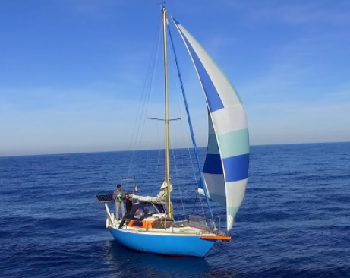
A quiet little zephyr tousles his hair and catches in the sails, pushing the ship along.

