LO: Shared reading
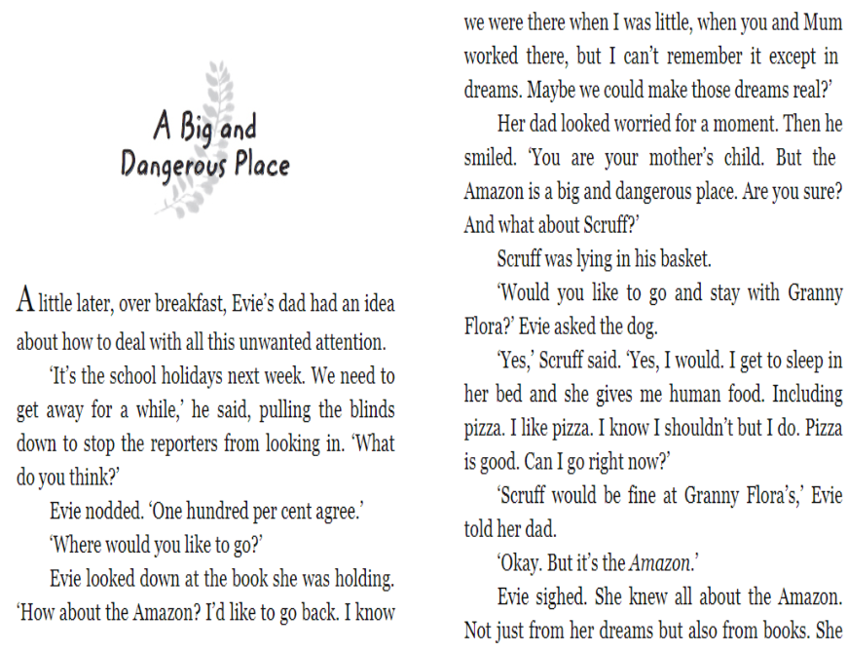

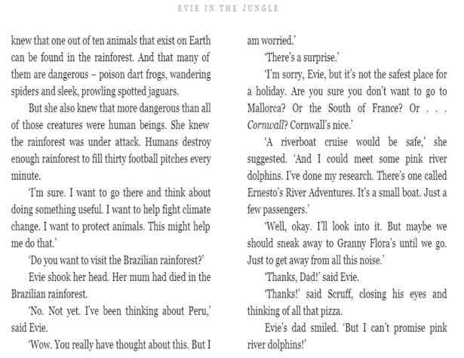
Retrieval
- What does Granny give Scruff that he knows he shouldn’t like?
- Why does Evie want to go to the Amazon?

Vocabulary
- ‘But maybe we should sneak away to Granny Flora’s until we go.’
What does the word sneak mean? Use sneak in a noun w sentence of your own.

Inference
- Why does Dad make the suggestion of going on holiday?
- How does scruff feel about going to Granny’s house? How do you know?

Sneak

Definition
to move, act, bring, put, or take in a sly or secret way
Sentence
Connor and James, who are always very naughty, tried to sneak into the cinema without paying.

