LO: Evie in the jungle
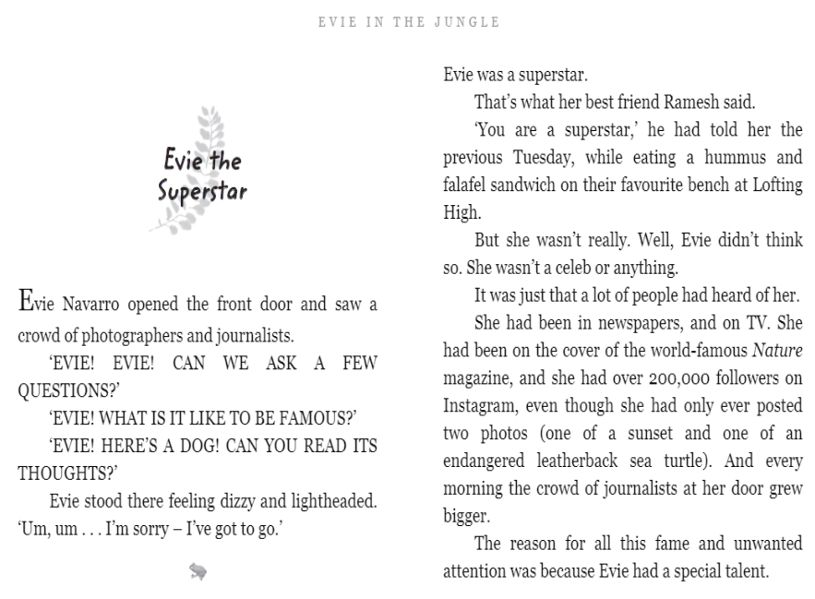

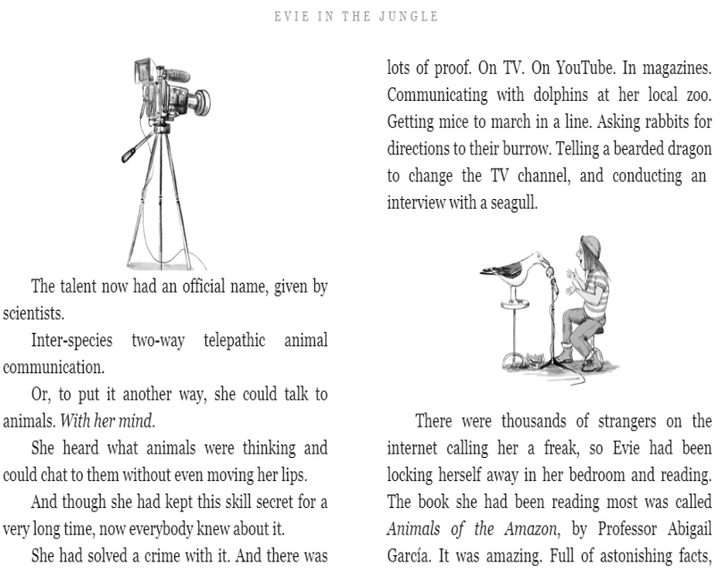

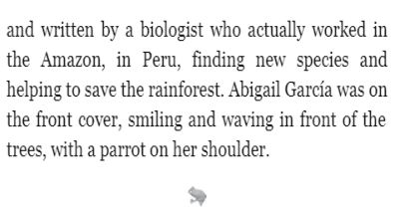
Retrieval
- How did the photographers and journalists make Evie feel?
- Who told Evie she was a superstar?
- Why was Evie receiving all this fame and attention?

Vocabulary
- ‘Full of astonishing facts’. What does the word astonishing mean?
- Use astonishing in a sentence.
Inference
- Why has Matt Haig used capital letters for when the journalists were talking?


Astonishing
Definition
causing a feeling of great surprise or wonder

Sentence
He showed an astonishing lack of concern for others.

