Monday 2nd November 2020

WALT: Shared reading Oliver Jeffers
- Find and underline the word that means completed in the text.

- Jeffers books are ‘highly acclaimed’. Is this a positive or negative phrase?

- True or false? Oliver Jeffers lives in Belfast, Northern Ireland.

- How many books has Oliver Jeffers written?

- Why do you think Jeffers moved to Brooklyn to work?
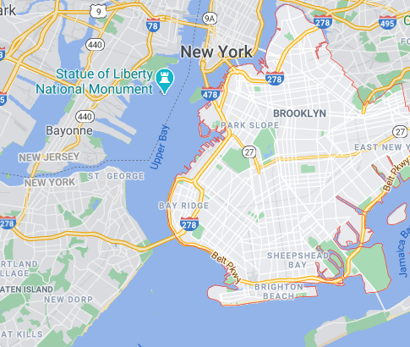

f. What kind of person is Oliver Jeffers? Watch his YouTube film
https://www.youtube.com/watch?v=w-8ydwV45no

