Pre learning task
Squirrels and Otters
Autumn term 2

Your task is to create a poster that will persuade people to holiday in Somerset.
You must include:
- Persuasive language
- Local attractions
- Places to visit
- Places to eat.
You may create your poster in any way you choose (draw and write, type), perhaps you could use Purple Mash?
We look forward to seeing what you have learnt about Somerset and the amazing things in our county.
Please bring in your pre learning task on Monday 30th October.

WAGOLL
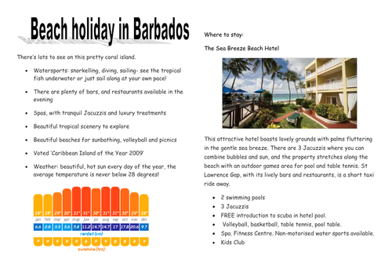
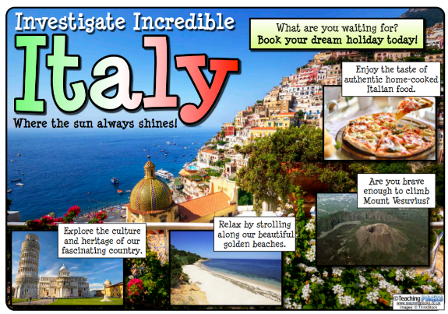
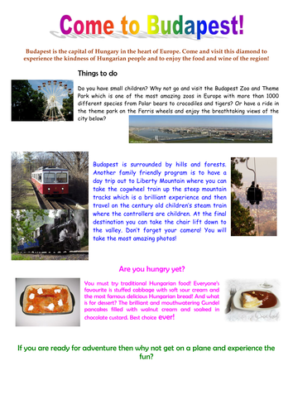
What A Good One looks Like

