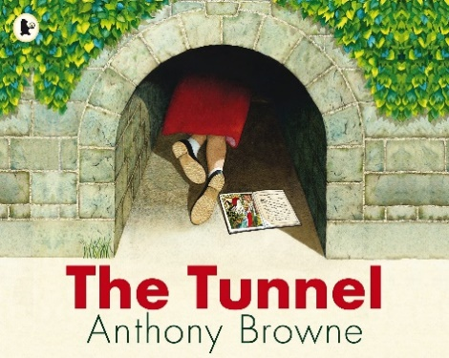  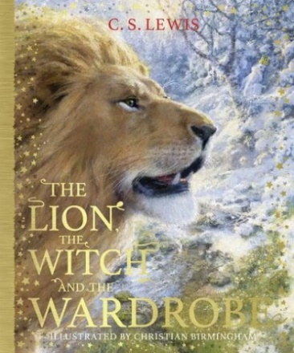 | Home challenges Autumn 2 Otters and Squirrels Year 3 and 4  Autumn Term 2  Should we go on a Southwest staycation?
  You can choose how you would like to present your homework. We are looking forward to seeing your homework completed to a high standard.
  Remember the Tourist Information Office is a great place to find about our area.

Find out about treehouse holidays in SW England.  Which is your favourite?  Why?  Design you own holiday destination treehouse.  Label it- or make it! | Visit the seaside and take pictures of erosion evidence.  Or  Do a ‘Candy (sweets) erosion’ experiment!  Record what you learn/ find out.  https://sugarspiceandglitter.com/easy-erosion-experiment/ | In science we are learning about plants.  Make some crazy cress hair eggs!  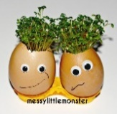 | Find out about plants that eat meat!  What are these plants called?  Where do they grow naturally?  Draw and label your favourite one! | Design a poster to educate people on the importance of bees.  What can people do to help these insects?  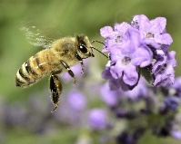
Create a postcard for a destination in the Southwest of England. Perhaps a place you have been and have enjoyed- or somewhere you would like  to go.  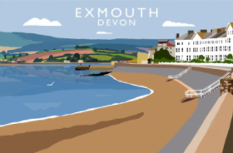 | Find out what a National Park is.  Which national Parks are we lucky enough to have in the Southwest?  Draw and name some of the wildlife you may find here. | Go on a walk and find 5 (or more) different sorts of deciduous leaves.  Draw, colour and label them with their correct names.   | Make some Turkish Deight sweets… or … design/ make a special box for the White Witch’s Turkish Delight!  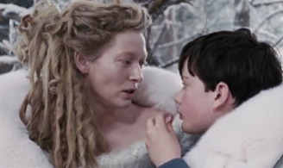 | Write a poem or an adventure story about a mysterious tunnel like the one describes in ‘Five go off to camp’ by Enid Blyton.  

