Otter and Squirrels pre-learning task
Spring 1
Romans

Your task is to make your own Roman shield. This can be out of cardboard, paper, wood or anything else you would like. You could even draw a picture of one or draw one on purple mash. This can be life size or a smaller version.

Here are some helpful links to help your making:
https://cimuseums.org.uk/wp-content/uploads/2020/04/Instructions-Roman-Shield.pdf
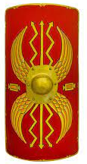
https://www.youtube.com/watch?v=YIbv92T_Nqc


